The Following are the tables has to be in your database & model design:

1. Users
2. Codekata
3. Attendance
4. Topics
5. Tasks
6. company_drives
7. mentors
8. students_activated_courses
9. courses

The following are the queries need to be executed

1. Create tables for the above list given

2. insert at least 5 rows of values in each table

3. get number problems solved in codekata by combining the users

4. display the no of company drives attended by a user

1. combine and display students_activated_courses and courses for a specific user groping them based on the course.
2. list all the mentors.
3. list the number of students that are assigned for a mentor.

**MODEL DESIGN**

Queries:

1. Create tables for the above list given

**Ans:**

**Syntax:**

Create table statement w/ optional table constraint and default value

CREATE TABLE IF NOT EXISTS mytable (

column *DataType* *TableConstraint* DEFAULT *default_value*,

another_column *DataType* *TableConstraint* DEFAULT *default_value*,

…

);

1. Table Name : Users

|  |  |
| --- | --- |
| Users-id | User Name |
| 1 | Sakthi |
| 2 | Kaaviya |
| 3 | Krishna |
| 4 | Veni |
| 5 | vel |

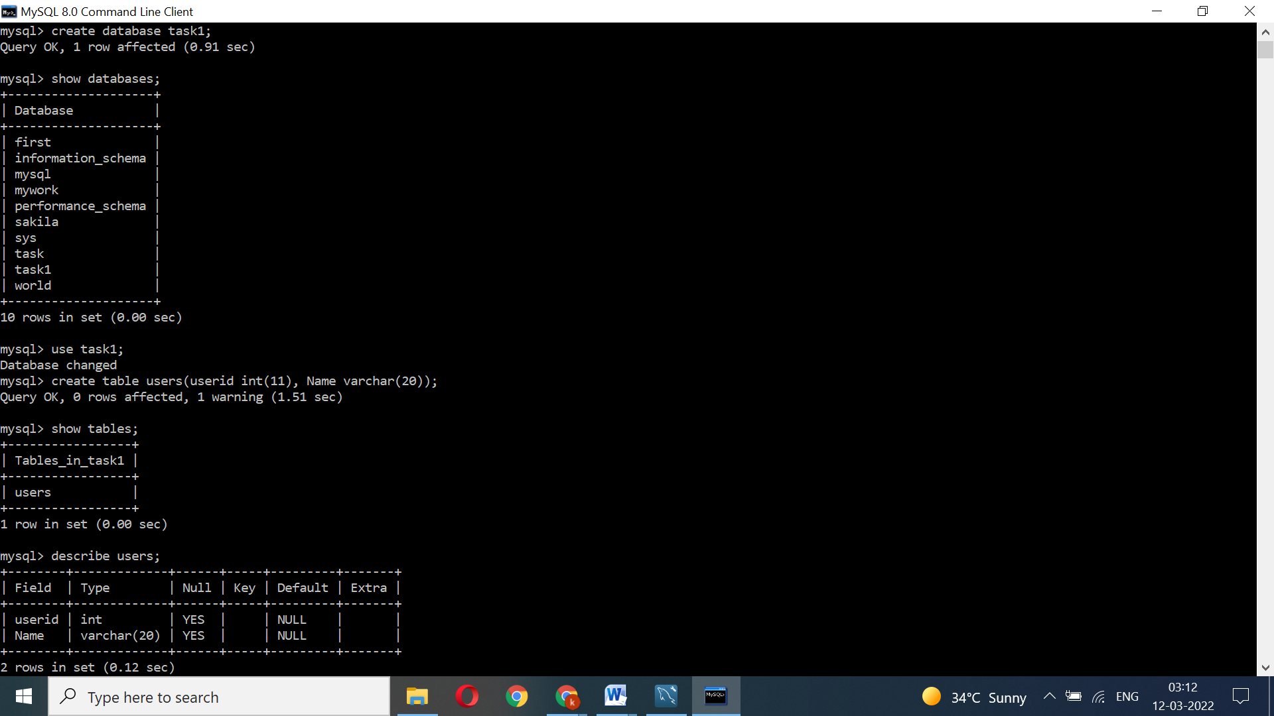

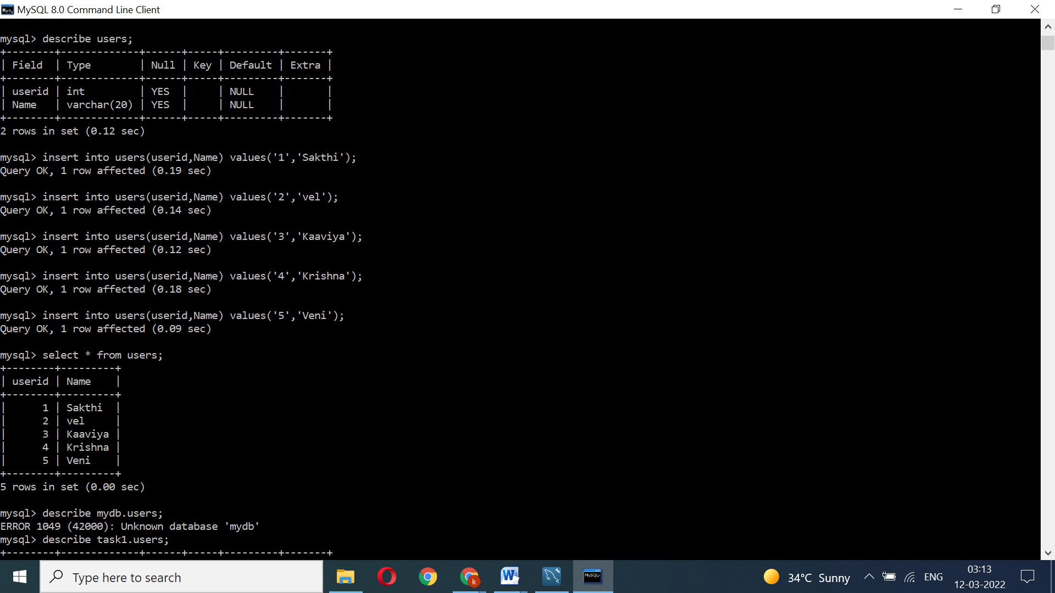

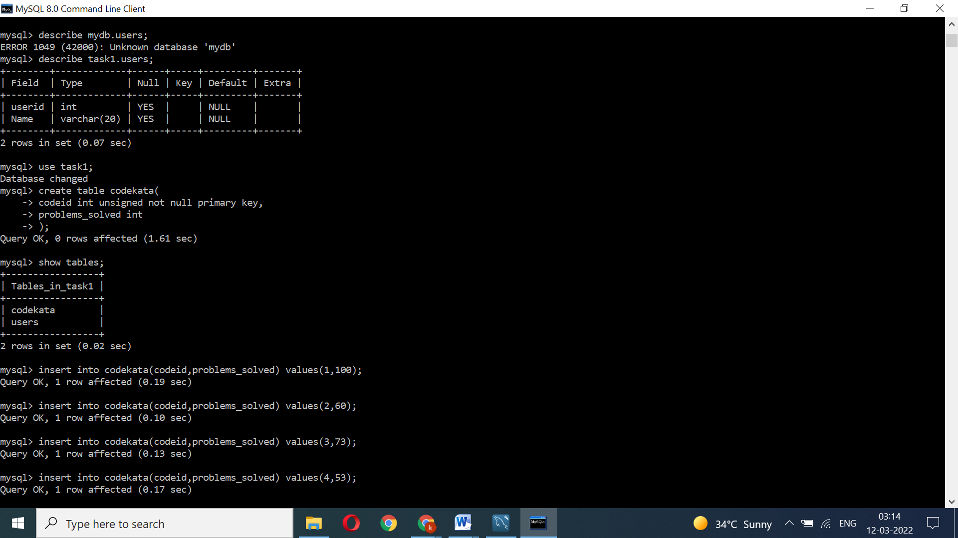

Syntax to insert row:

INSERT INTO table_name (column1, column2, column3, ...)  
VALUES (value1, value2, value3, ...);

Query number: 3

3. get number problems solved in codekata by combining the users

Combining user table and Codekata table

|  |  |  |
| --- | --- | --- |
| Users-id | User Name | Codekata Problems solved |
| 1 | Sakthi | 100 |
| 2 | Kaaviya | 50 |
| 3 | Krishna | 25 |
| 4 | Veni | 45 |
| 5 | vel | 52 |

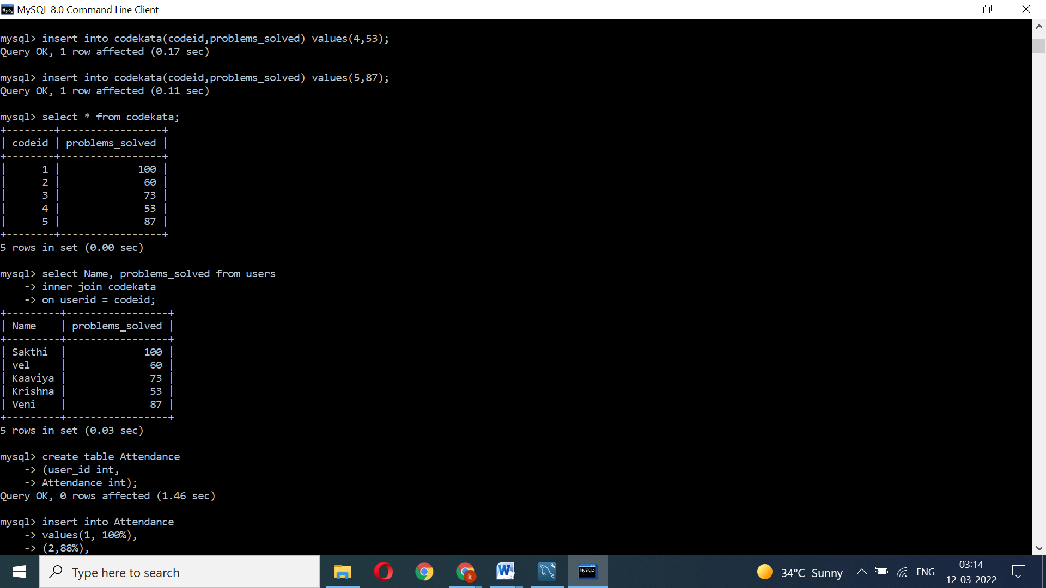

1. Table Name : Codekata

|  |  |
| --- | --- |
| Codeid | Codekata Problems solved |
| 1 | 100 |
| 2 | 50 |
| 3 | 25 |
| 4 | 45 |
| 5 | 52 |

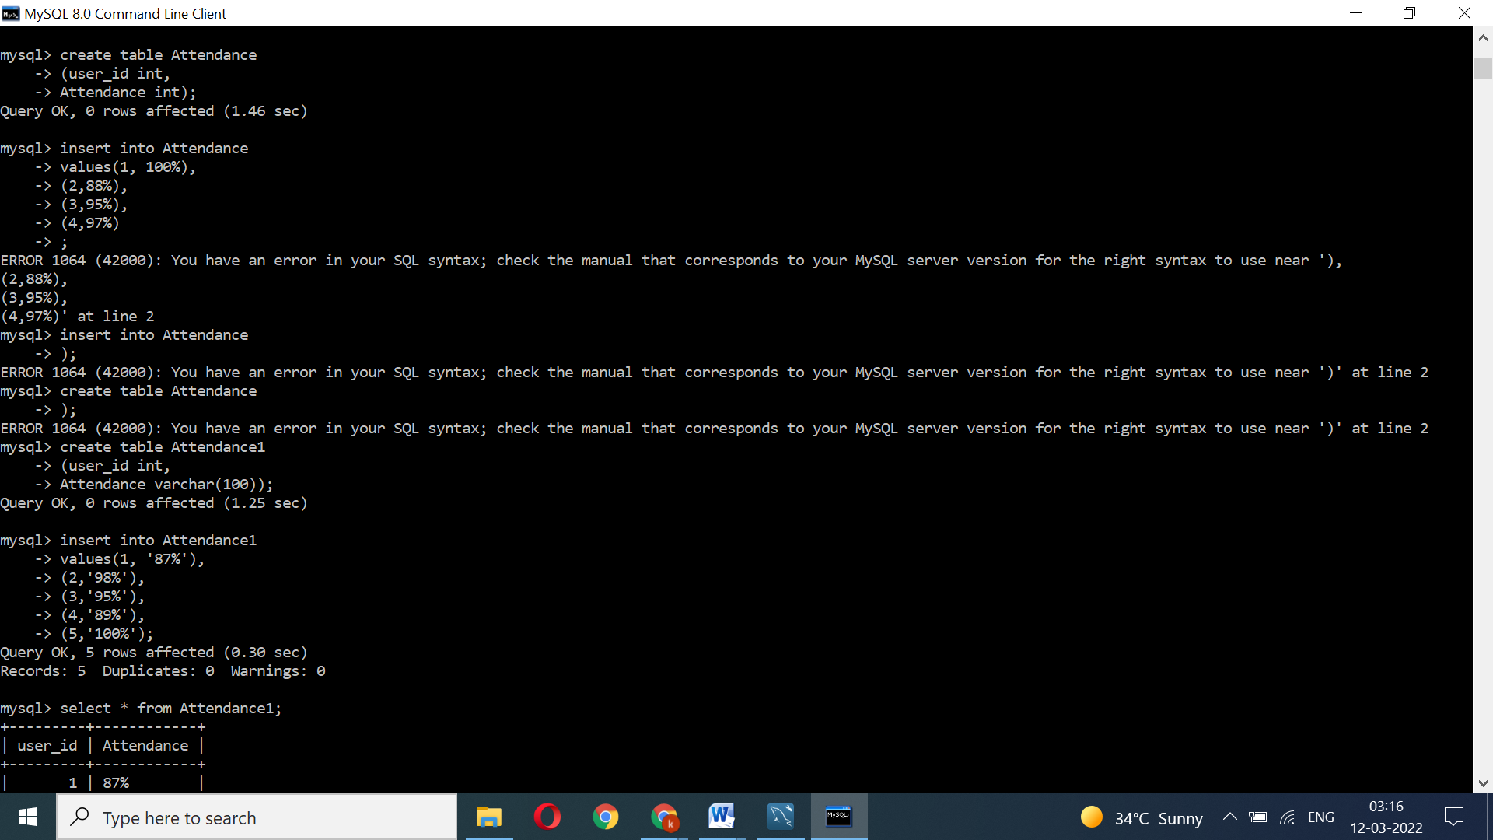

1. Table Name : Attendance

|  |  |
| --- | --- |
| User_id | Attendance1 |
| 1 | 87% |
| 2 | 98% |
| 3 | 95% |
| 4 | 89% |
| 5 | 100% |

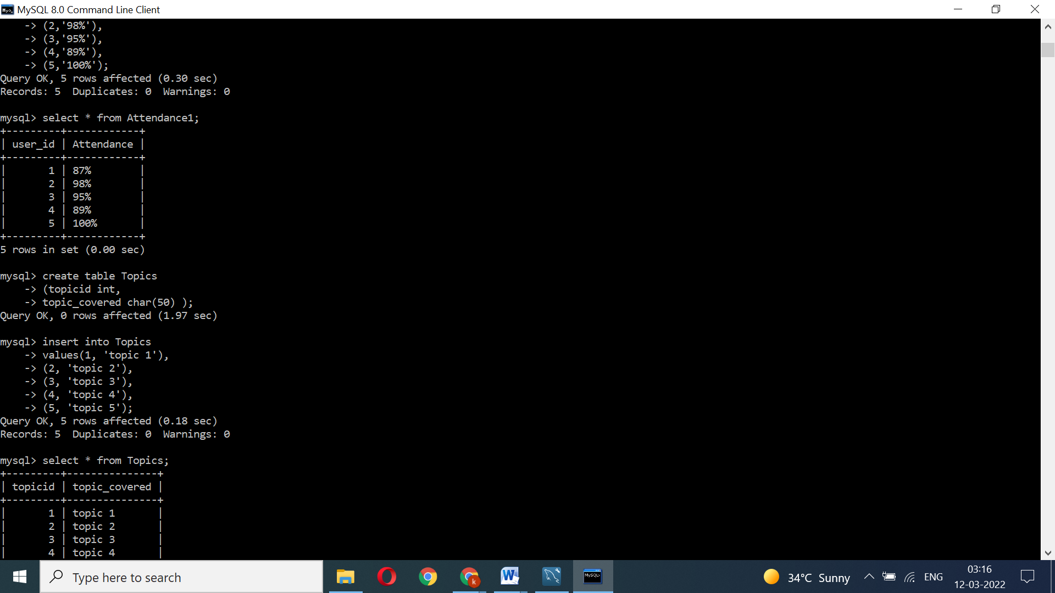

1. Table Name : Topics

|  |  |
| --- | --- |
| Topicid | Topics |
| 1 | Topic 1 |
| 2 | Topic 2 |
| 3 | Topic 3 |
| 4 | Topic 4 |
| 5 | Topic 5 |

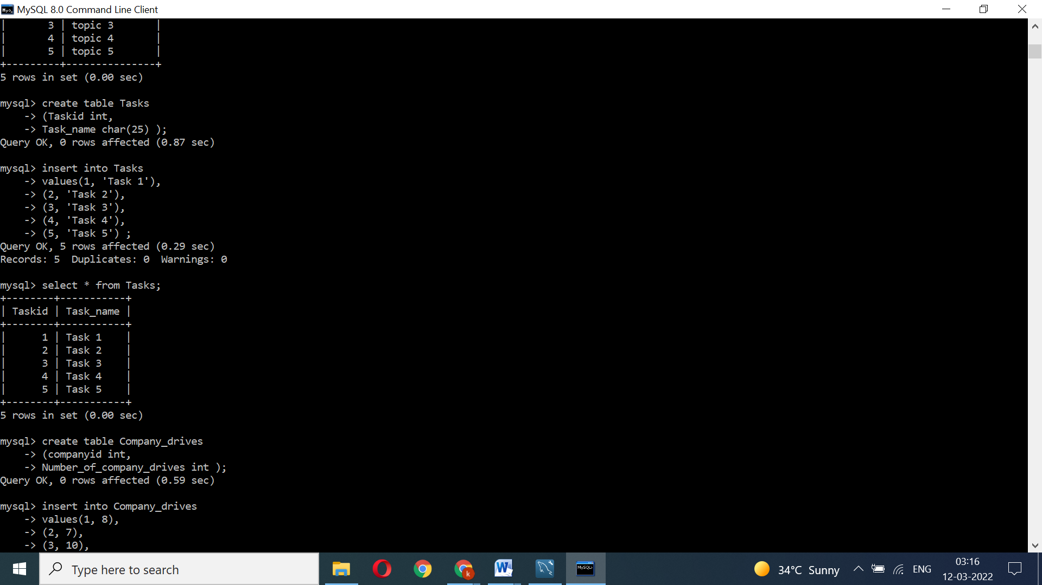

1. Table Name : Tasks

|  |  |
| --- | --- |
| Tasked | Tasks |
| 1 | Task 1 |
| 2 | Task 2 |
| 3 | Task 3 |
| 4 | Task 4 |
| 5 | Task 5 |

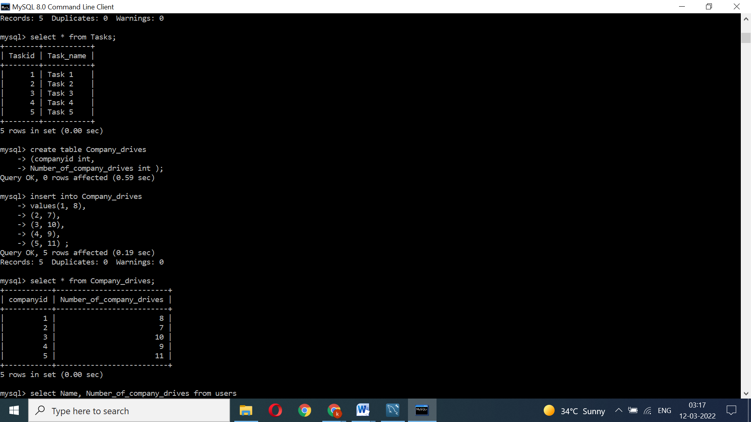

Query no: 4

4. display the no of company drives attended by a user

|  |  |
| --- | --- |
| Username | Number_of_Company_drives |
| Sakthi | 8 |
| Vel | 7 |
| Kaaviya | 10 |
| Krisha | 9 |
| veni | 11 |

1. Table Name : Company_drives

|  |  |
| --- | --- |
| Companyid | Number_of_Company_drives |
| 1 | 8 |
| 2 | 7 |
| 3 | 10 |
| 4 | 9 |
| 5 | 11 |

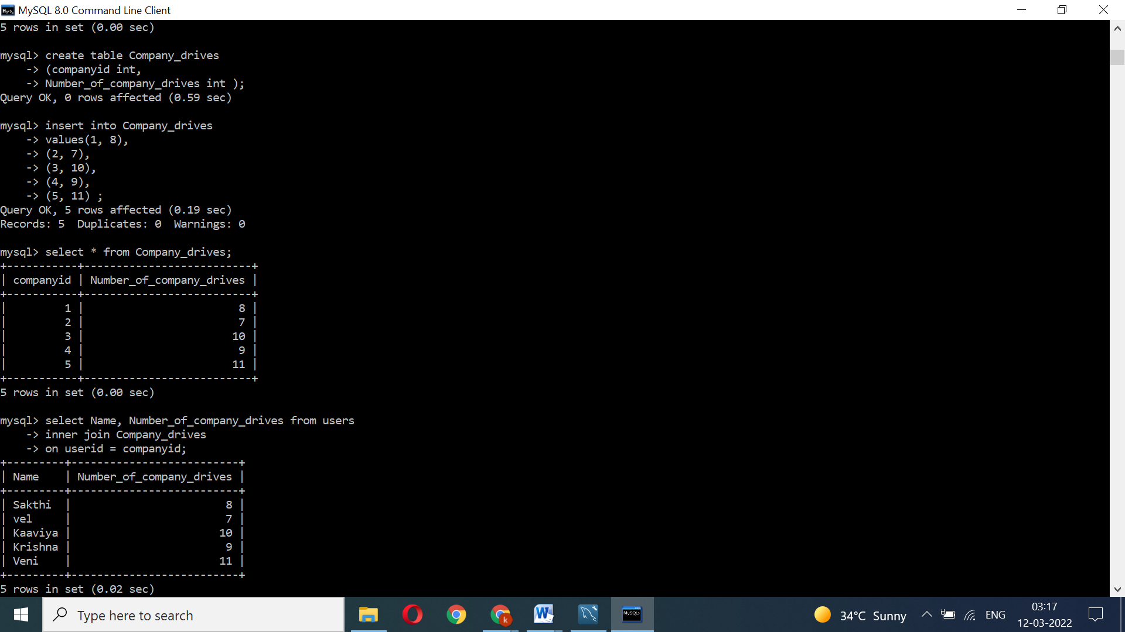

1. Table Name : Mentors

Query no. 6

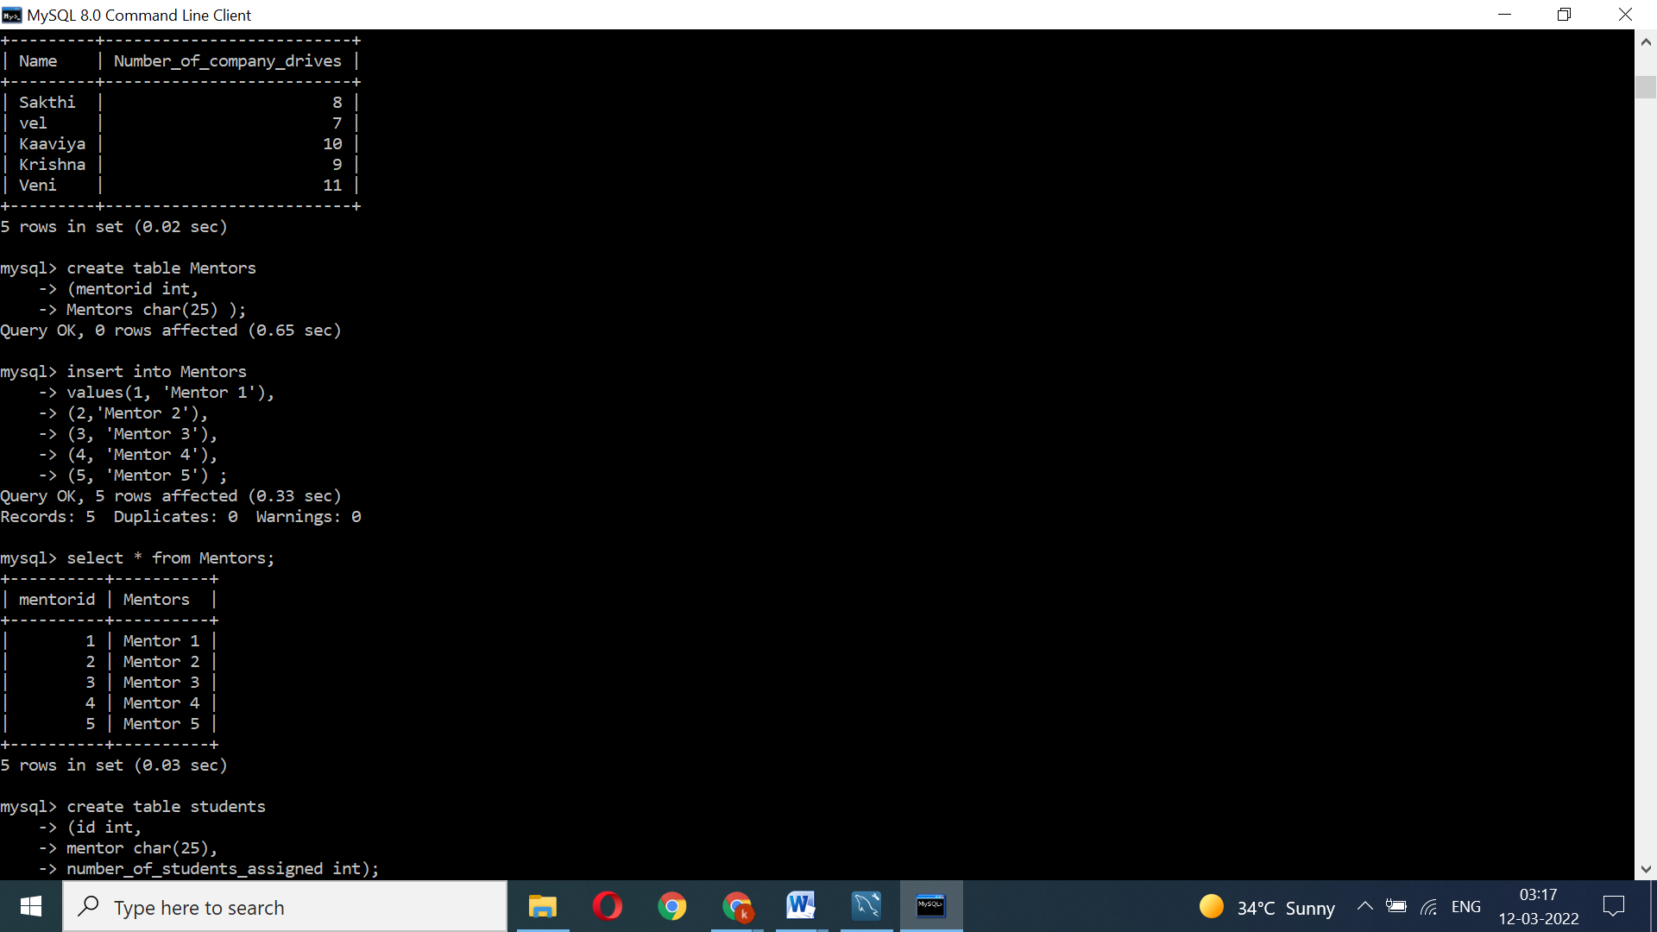

6. list all the mentors

|  |  |
| --- | --- |
| Mentored | Mentors |
| 1 | Mentor 1 |
| 2 | Mentor 2 |
| 3 | Mentor 3 |
| 4 | Mentor 4 |
| 5 | Mentor 5 |

Query no. 7

7.list the number of students that are assigned for a mentor 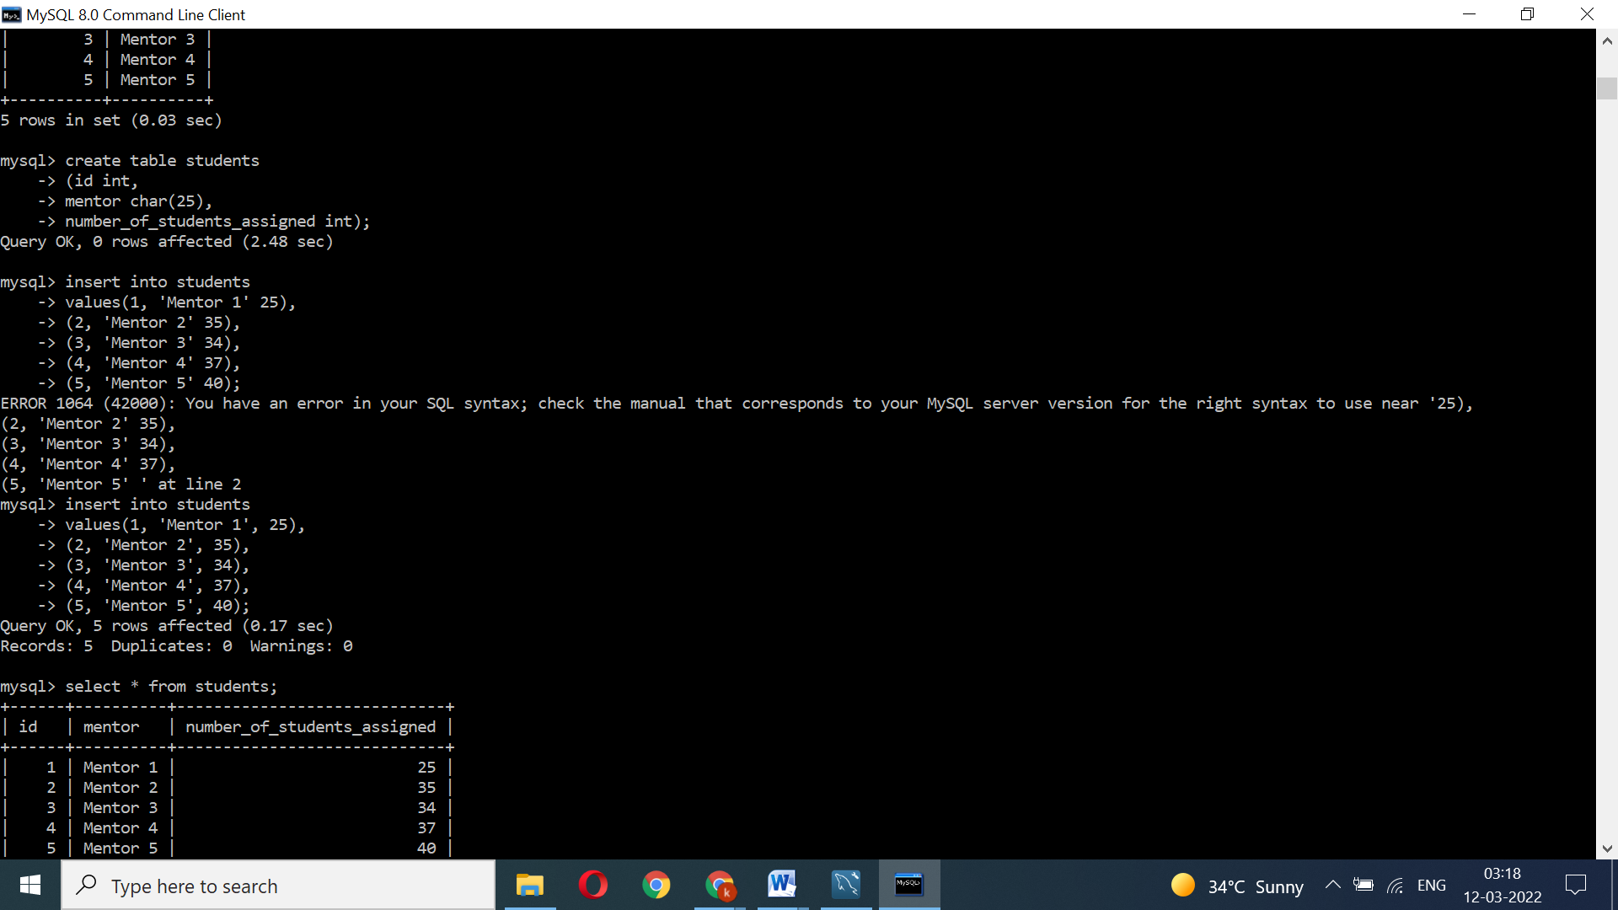

1. Table Name : students_activated_courses

|  |  |  |
| --- | --- | --- |
| Students_id | students_activated_courses | Course_count |
| 1 | Course 1 | 10 |
| 2 | Course 2 | 15 |
| 3 | Course 3 | 8 |
| 4 | Course 4 | 16 |
| 5 | Course 5 | 11 |

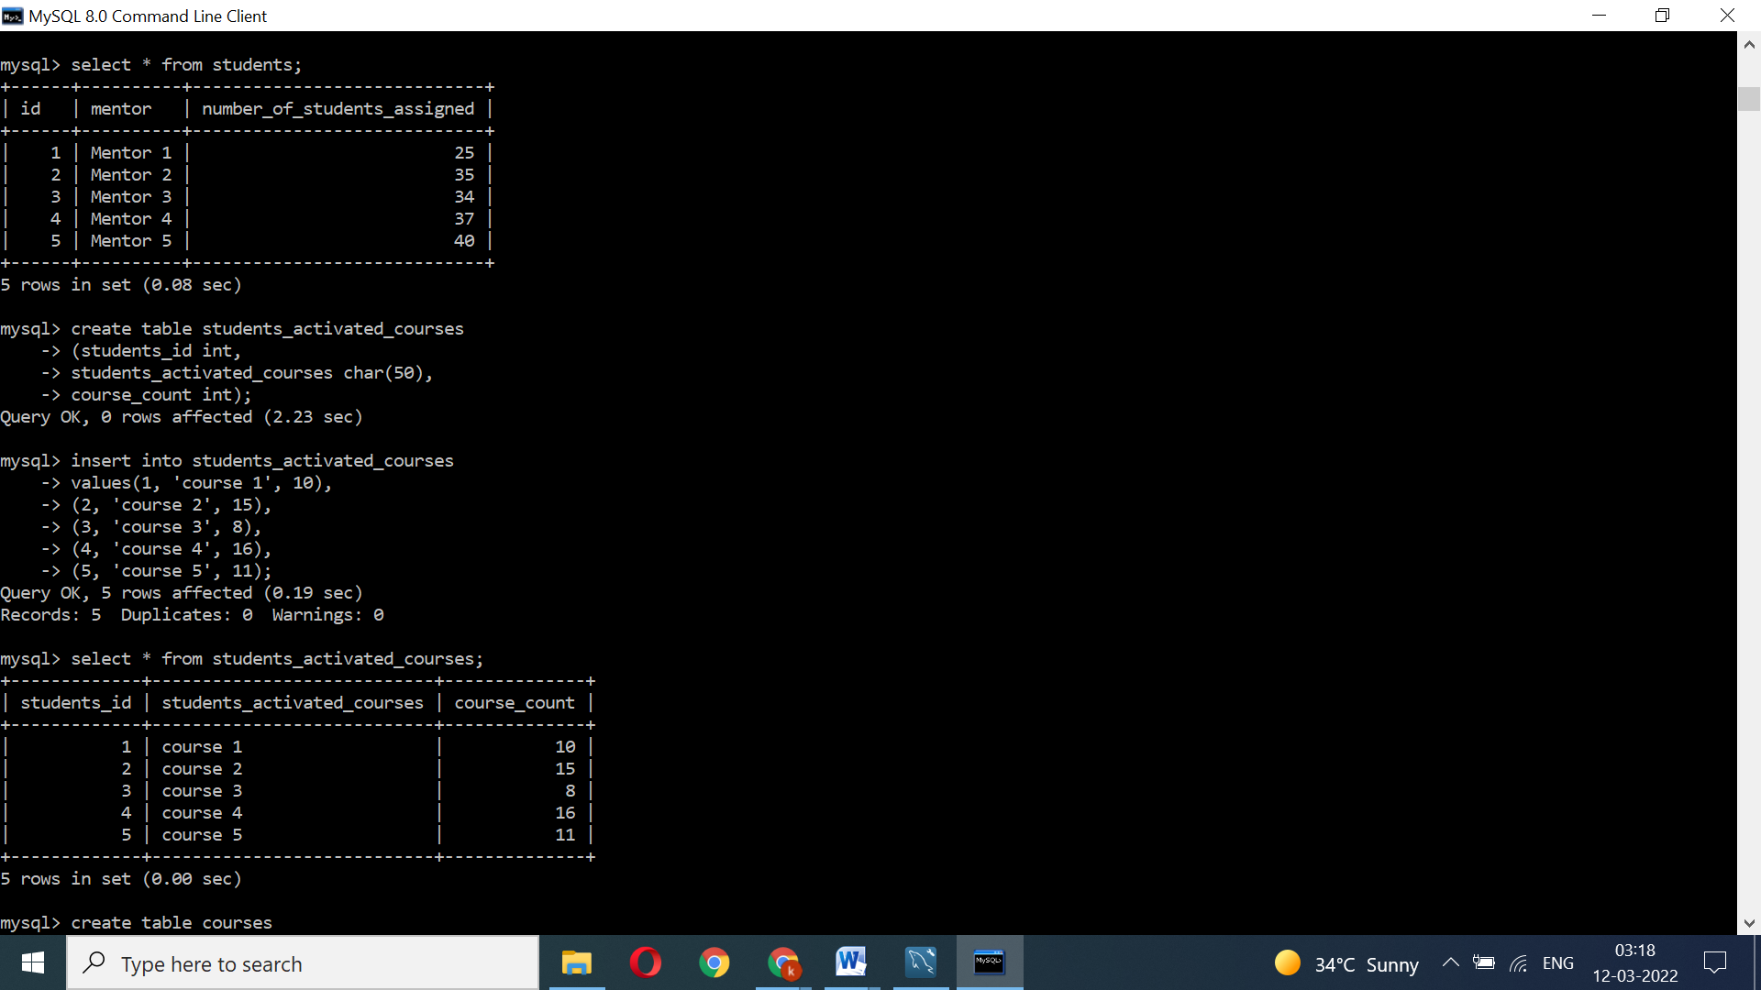

Query no: 5 Combine and display students_activated_courses and courses for a specific user grouping them based on the course. 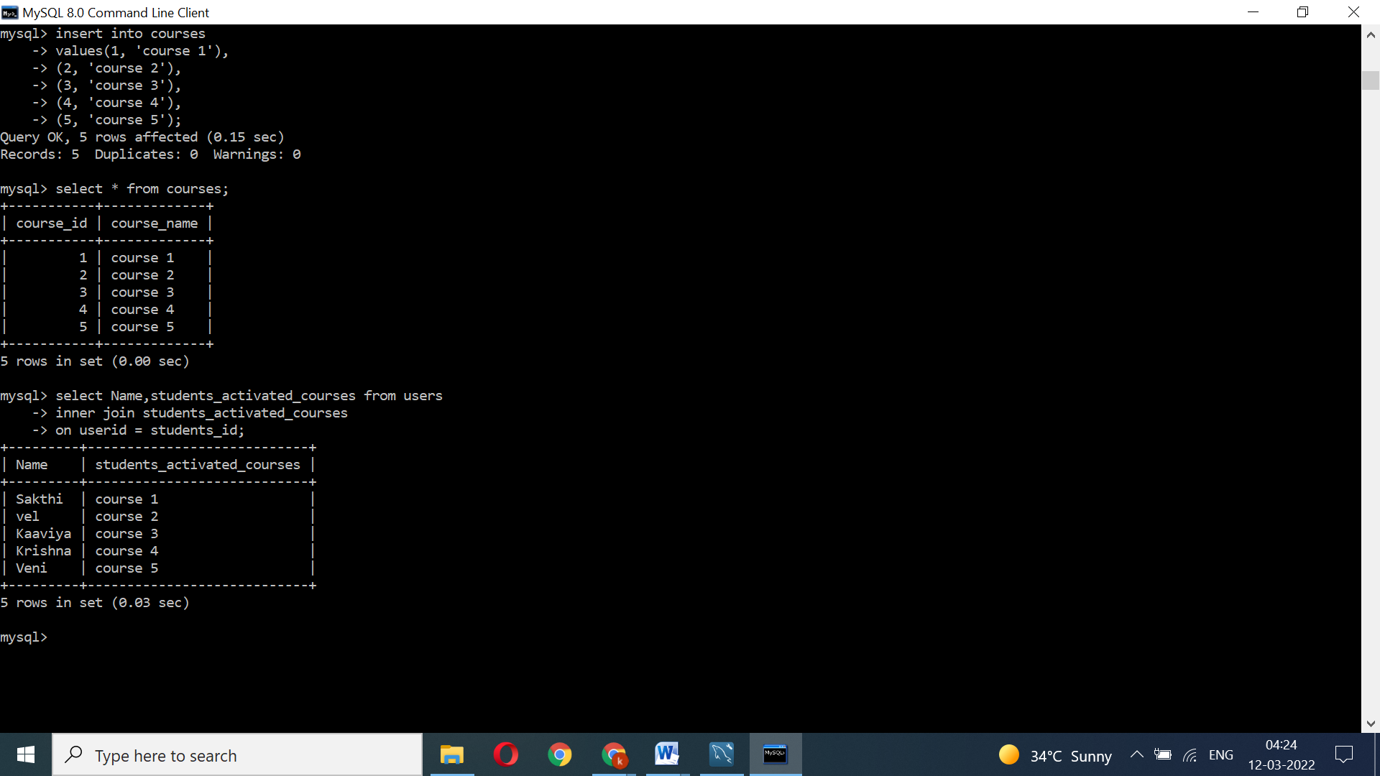

1. Table Name :Courses

|  |  |
| --- | --- |
| Course_id | Course_name |
| 1 | Course 1 |
| 2 | Course 2 |
| 3 | Course 3 |
| 4 | Course 4 |
| 5 | Course 5 |

